

JAVAASSINGMENT-1

NAME: Shubham Dutta

SEC: 2B

ROLL: 58

ENROLLMENT NO: 12019009022112

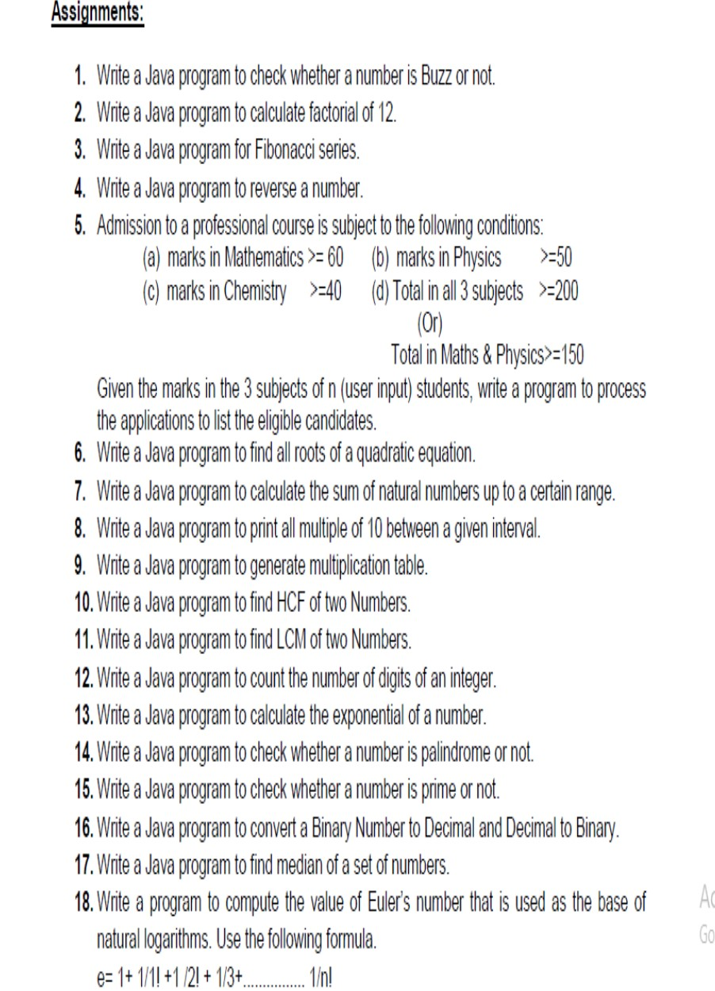

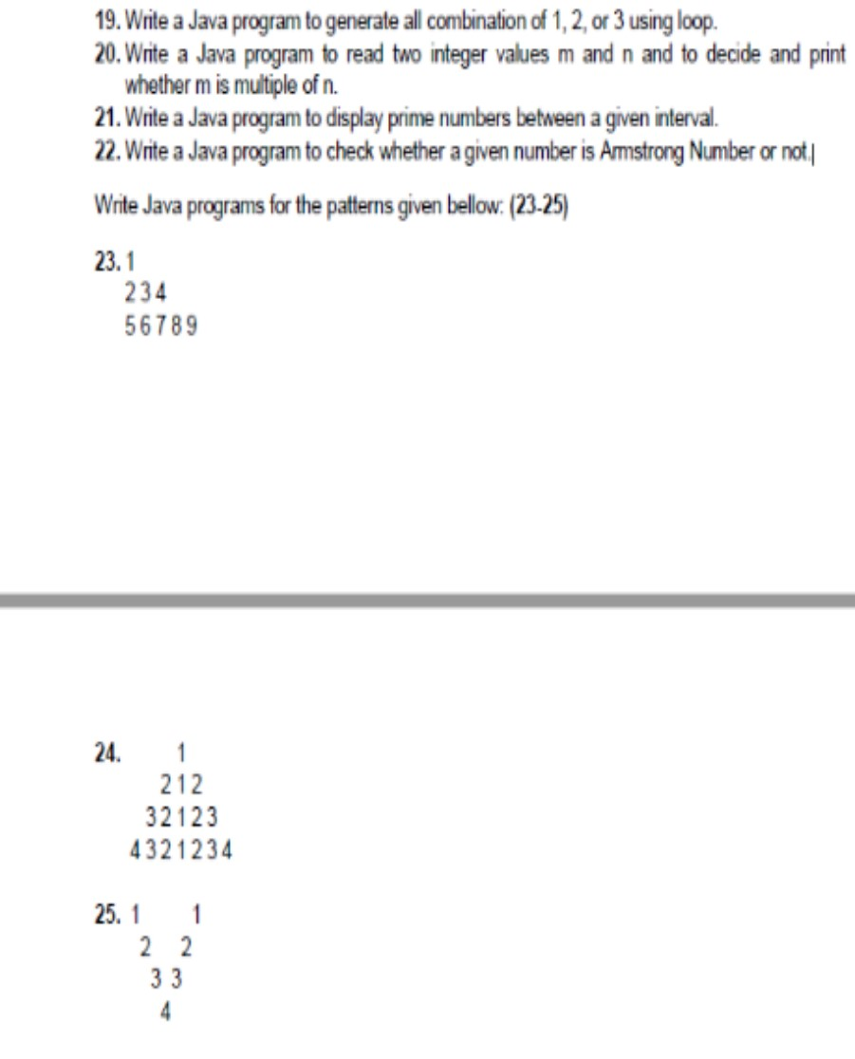

1.ANS:

SourceCode:

|  |
| --- |
| importjava.util.Scanner; |
| publicclassbuzzno{ |
| publicstaticvoidmain(String[]args){ |
| Scannerscanner=newScanner(System.in); |
| System.out.println("EnteryourNumber:"); |
| intnumber; |
| number=scanner.nextInt(); |
| if(number%7==0||number%10==7){ |
| System.out.println("ITISBUZZNUMBER"); |
| }else{ |
| System.out.println("ITISNOTBUZZNUMBER"); |
| } |
| } |
| } |

Output:

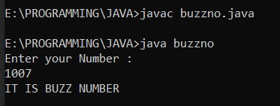

2.ANS:

SourceCode:

|  |
| --- |
| importjava.util.Scanner; |
| publicclassfactorial{ |
| publicstaticvoidmain(String[]args){ |
| intn,fact; |
| fact=1; |
| Scannersc=newScanner(System.in); |
| n=sc.nextInt(); |
| for(inti=1;i<=n;i++){ |
| fact=fact*i; |
| } |
| System.out.println("Factorialof"+n+"is:"+fact); |
| } |
| } |

Output:

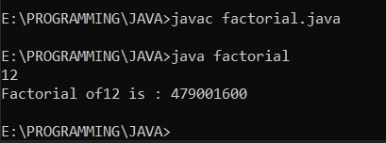

3.ANS:

SourceCode:

|  |
| --- |
| importjava.util.Scanner; |
| classfibonacci{ |
| staticintfibonacciSeries(intx){ |
| if(x<=1){ |
| returnx; |
| } |
| else{ |
| returnfibonacciSeries(x-1)+fibonacciSeries(x-2); |
| } |
| } |
| publicstaticvoidmain(Stringargs[]){ |
| intcount; |
| Scannersc=newScanner(System.in); |
| count=sc.nextInt(); |
| for(inti=0;i<count;i++){ |
| System.out.println(fibonacciSeries(i)); |
| } |
| } |
| } |

Output:

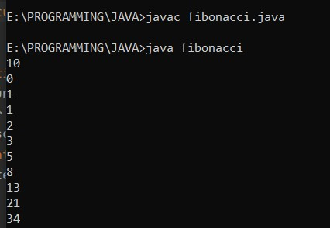

4.ANS:

SourceCode:

|  |
| --- |
| importjava.util.Scanner; |
| publicclassreverseNum{ |
|  |
| publicstaticvoidmain(String[]args){ |
|  |
| intnum,reversed=0; |
| Scannersc=newScanner(System.in); |
| num=sc.nextInt(); |
| while(num!=0){ |
| intdigit=num%10; |
| reversed=reversed*10+digit; |
| num/=10; |
| } |
|  |
| System.out.println("ReversedNumber:"+reversed); |
| } |
| } |

Output:

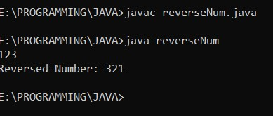

5.ANS:

SourceCode:

importjava.util.Scanner; publicclassadmission{

publicstaticvoidmain(String[]args){

doublemath,phy,chem; intn;

Scannersc=newScanner(System.in);

System.out.print("EnterTheNumberofStudent:"); n=sc.nextInt(); for(inti=1;i<=n;i++){

System.out.print("EnterMathMarks:"); math=sc.nextDouble();

System.out.print("EnterPhysicsMarks:"); phy=sc.nextDouble();

System.out.print("EnterChemistryMarks:"); chem=sc.nextDouble();

if((math>=60&&phy>=50&&chem>=40&&(math

+phy+chem)>=200)||((math+phy)>=150)){

System.out.println("Student"+i+"EligibleForCourse");

}else{

System.out.println("Student"+i+"NotEligibleFor

Course");

}

}

}

}

Output:

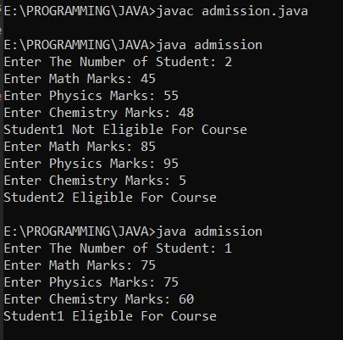

6.ANS:

SourceCode:

|  |
| --- |
| publicclassrootsQuadEq{ |
| publicstaticvoidmain(String[]args){ |
| doublea=3.6,b=8.4,c=7.6; |
| doubleroot1,root2; |
| doubledeterminant=b*b-4*a*c; |
| if(determinant>0){ |
| root1=(-b+Math.sqrt(determinant))/(2*a); |
| root2=(-b-Math.sqrt(determinant))/(2*a); |
| System.out.format("root1=%.2fandroot2=%.2f",root1, |
| root2); |
| }elseif(determinant==0){ |
| root1=root2=-b/(2*a); |
| System.out.format("root1=root2=%.2f;",root1); |
| }else{ |
| doublereal=-b/(2*a); |
| doubleimaginary=Math.sqrt(-determinant)/(2*a); |
| System.out.format("root1=%.2f+%.2fi",real,imaginary); |
| System.out.format("\nroot2=%.2f-%.2fi",real,imaginary); |
| } |
| } |
| } |

Output:

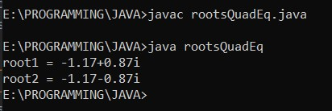

7.ANS:

SourceCode:

|  |
| --- |
| importjava.util.Scanner; |
| publicclasssumNaturalNum{ |
| intsum=0,j=0; |
|  |
| publicstaticvoidmain(String[]args){ |
| intn,sum; |
| Scanners=newScanner(System.in); |
| System.out.print("EntertheRange:"); |
| n=s.nextInt(); |
| sum=0; |
| for(inti=0;i<=n;i++){ |
| sum=sum+i; |
| } |
| System.out.print("RESULT:"+sum); |
| } |
| } |

Output:

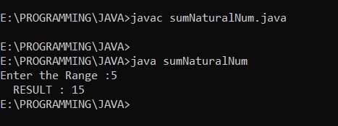

8.ANS:

SourceCode:

|  |
| --- |
| importjava.util.Scanner; |
| publicclassMultipleof10{ |
| publicstaticvoidmain(String[]args){ |
| Scannersc=newScanner(System.in); |
| intupperlimit,lowerlimit; |
| upperlimit=sc.nextInt(); |
| lowerlimit=sc.nextInt(); |
| for(inti=lowerlimit;i<=upperlimit;i++){ |
| if(i%10==0){ |
| System.out.print(i+","); |
| } |
| } |
| } |
| } |

Output:

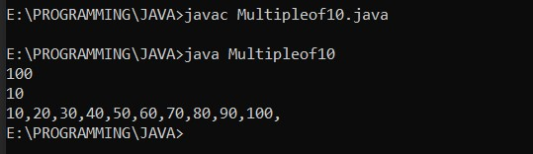

9.ANS:

SourceCode:

|  |
| --- |
| importjava.util.Scanner; |
| publicclassmultiplicationTable{ |
|  |
| publicstaticvoidmain(String[]args){ |
| Scannerc=newScanner(System.in); |
| intnum=c.nextInt(); |
| for(inti=1;i<=10;++i) |
| { |
| System.out.printf("%d*%d=%d\n",num,i,num*i); |
| } |
| } |
| } |

Output:

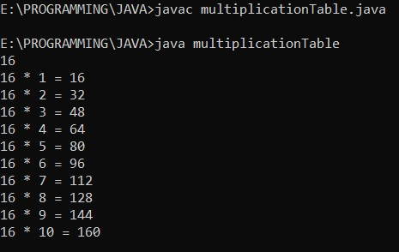

10.ANS:

SourceCode:

|  |
| --- |
| importjava.util.Scanner; |
| publicclasshcfOf2nums{ |
| publicstaticvoidmain(Stringargs[]){ |
| inta,b,i,hcf=0; |
| Scannersc=newScanner(System.in); |
| System.out.println("Enterfirstnumber::----->"); |
| a=sc.nextInt(); |
| System.out.println("Entersecondnumber::----->"); |
| b=sc.nextInt(); |
|  |
| for(i=1;i<=a||i<=b;i++){ |
| if(a%i==0&&b%i==0) |
| hcf=i; |
| } |
| System.out.println("HCFofgiventwonumbersis::"+hcf); |
| } |
| } |

Output:

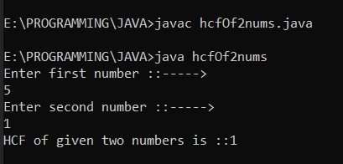

11.ANS:

SourceCode:

|  |
| --- |
| importjava.util.Scanner; |
| publicclasslcmof2nums{ |
| publicstaticvoidmain(Stringargs[]){ |
| inta,b,i,hcf=0; |
| Scannersc=newScanner(System.in); |
| System.out.println("Enterfirstnumber::----->"); |
| a=sc.nextInt(); |
| System.out.println("Entersecondnumber::----->"); |
| b=sc.nextInt(); |
|  |
| for(i=1;i<=a||i<=b;i++){ |
| if(a%i==0&&b%i==0) |
| hcf=i; |
| } |
| System.out.println("HCFofgiventwonumbersis::"+hcf); |
| intlcm; |
| lcm=(a*b)/hcf; |
| System.out.println("LCMofgiventwonumbersis::"+lcm); |
| } |
| } |

Output:

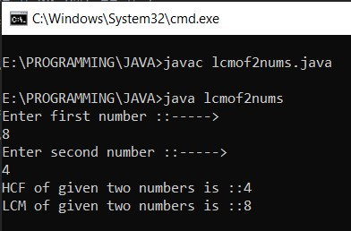

12.ANS:

SourceCode:

|  |
| --- |
| importjava.util.Scanner; |
| publicclasscountDigitsofInt{ |
|  |
| publicstaticvoidmain(String[]args){ |
|  |
| intcount=0,num; |
| Scannerin=newScanner(System.in); |
| num=in.nextInt(); |
| while(num!=0){ |
| //num=num/10 |
| num/=10; |
| ++count; |
| } |
|  |
| System.out.println("Numberofdigits:"+count); |
| } |
| } |

Output:

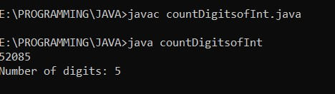

13.ANS:

SourceCode:

|  |
| --- |
| importjava.lang.Math; |
| importjava.util.Scanner; |
| publicclassexponentialOfNum{ |
| publicstaticvoidmain(String[]args){ |
| //declaringandinitializingsomedoublevalues |
| doublea; |
| Scannersc=newScanner(System.in); |
| a=sc.nextDouble(); |
| //printingtheirexponentialvalues |
| System.out.println("Exponentialvalueof"+a+"="+ |
| Math.exp(a)); |
| } |
| } |

Output:

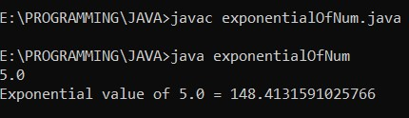

14.ANS:

SourceCode:

|  |
| --- |
| importjava.util.Scanner; |
| publicclassPalinedromeNum{ |
|  |
| publicstaticvoidmain(String[]args){ |
| Scannersc=newScanner(System.in); |
| intnum,reversedInteger=0,remainder,originalInteger; |
| num=sc.nextInt(); |
| originalInteger=num; |
| while(num!=0) |
| { |
| remainder=num%10; |
| reversedInteger=reversedInteger*10+remainder; |
| num/=10; |
| } |
|  |
| if(originalInteger==reversedInteger) |
| System.out.println(originalInteger+"isapalindrome |
| NUMBER."); |
| else |
| System.out.println(originalInteger+"isnotapalindrome |
| NUMBER."); |
| } |
| } |

Output:

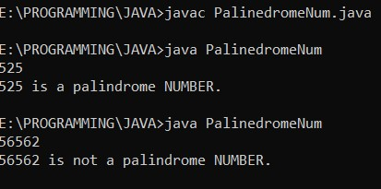

15.ANS:

SourceCode:

|  |
| --- |
| importjava.util.*; |
| publicclassPrime{ |
|  |
| publicstaticvoidmain(String[]args){ |
|  |
| intnum; |
| Scannersc=newScanner(System.in); |
| num=sc.nextInt(); |
| booleanflag=false; |
| for(inti=2;i<=num/2;++i){ |
| //conditionfornonprimenumber |
| if(num%i==0){ |
| flag=true; |
| break; |
| } |
| } |
|  |
| if(!flag) |
| System.out.println(num+"isaprimenumber."); |
| else |
| System.out.println(num+"isnotaprimenumber."); |
| } |
| } |

Output:

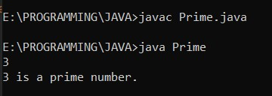

16.ANS:

SourceCode:

DecimaltoBinary→

|  |
| --- |
| importjava.util.*; |
| classdecimalToBinary |
| { |
| publicstaticvoidmain(Stringarg[]) |
| { |
|  |
| Scannersc=newScanner(System.in); |
| System.out.println("Enteradecimalnumber"); |
| intn=sc.nextInt(); |
| intbin[]=newint[100]; |
| inti=0; |
| while(n>0) |
| { |
| bin[i++]=n%2; |
| n=n/2; |
| } |
| System.out.print("Binarynumberis:"); |
| for(intj=i-1;j>=0;j--) |
| { |
| System.out.print(bin[j]); |
| } |
| } |
| } |

|  |
| --- |
| importjava.util.Scanner; |
| classbinaryTodecimal{ |
| publicstaticvoidmain(Stringargs[]){ |
| Scannerinput=newScanner(System.in); |
| System.out.print("Enterabinarynumber:"); |
| StringbinaryString=input.nextLine(); |
| System.out.println("Output:"+Integer.parseInt(binaryString,2)); |
| } |
| } |

BinarytoDecimal→ Output:

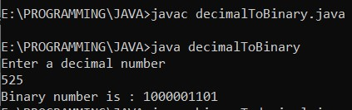

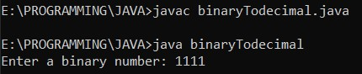

17.ANS:

SourceCode:

|  |
| --- |
|  |
| publicclassMedian |
| { |
| publicstaticvoidmain(Stringarg[]) |
| { |
| intn=5; |
| doublea[]=newdouble[n]; |
| a[0]=10; |
| a[1]=20; |
| a[2]=30; |
| a[3]=40; |
| a[4]=50; |
|  |
| doublem=0; |
| if(n%2==1) |
| { |
| m=a[(n+1)/2-1]; |
| } |
| else |
| { |
| m=(a[n/2-1]+a[n/2])/2; |
| } |
|  |
| System.out.println("Median:"+m); |
| } |

}

Output:

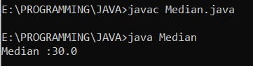

18.ANS:

SourceCode:

|  |
| --- |
| importjava.io.*; |
|  |
| publicclassEulersFormula{ |
|  |
| //Utilityfunctiontofind |
| staticintfactorial(intn) |
| { |
| intres=1; |
| for(inti=2;i<=n;i++) |
| res*=i; |
| returnres; |
| } |
|  |
| staticdoublesum(intn) |
| { |
| doublesum=0; |
| for(inti=1;i<=n;i++) |
| sum+=1.0/factorial(i); |
| returnsum; |
| } |
|  |
| publicstaticvoidmain(String[]args) |
| { |
| intn=5; |
| System.out.println(sum(n)); |
| } |
| } |

Output:

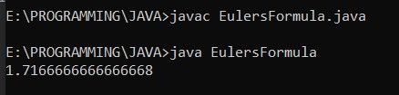

19.ANS:

SourceCode:

|  |
| --- |
| importjava.util.Scanner; |
| publicclassCombinationOf3Nums{ |
| publicstaticvoidmain(String[]args){ |
| inta,b,c; |
| System.out.print("ENTER1STNUMBER:"); |
| Scannersc=newScanner(System.in); |
| a=sc.nextInt(); |
| System.out.print("ENTER2NDNUMBER:"); |
| b=sc.nextInt(); |
| System.out.print("ENTER3RDNUMBER:"); |
| c=sc.nextInt(); |
| int[]input={a,b,c}; |
| for(intx=0;x<input.length;x++){ |
| for(inty=0;y<input.length;y++){ |
| for(intz=0;z<input.length;z++){ |
| if(x!=y&&y!=z&&z!=x){ |
| System.out.println(input[x]+""+input[y]+""+ |
| input[z]); |
| } |
| } |
| } |
| } |
| } |
| } |

Output:

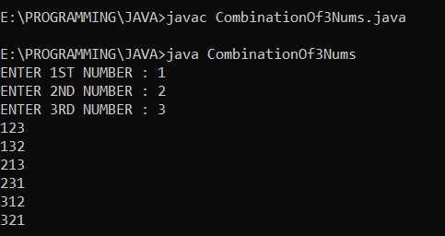

20.ANS:

SourceCode: importjava.util.Scanner; publicclassmAndnMultiples{

publicstaticvoidmain(String[]args)

{

intm,n;

Scannerscanner=newScanner(System.in); m=scanner.nextInt(); n=scanner.nextInt(); if(m>n){

if(m%n==0){

System.out.println(m+"ismultipleof"+n);

}

else{

System.out.println(m+"isnotmultipleof"+n);

}

}

else{

if(n%m==0){

System.out.println(n+"ismultipleof"+m);

}

else{

System.out.println(n+"isnotmultipleof"+m);

}

}

}

}

Output:

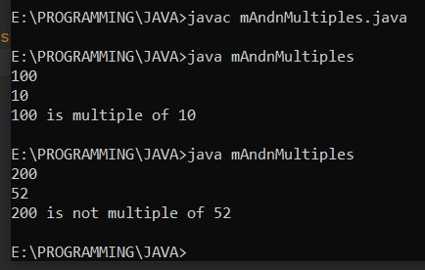

21.ANS:

SourceCode:

|  |
| --- |
| importjava.util.Scanner; |
| publicclassprimeGivenRange{ |
|  |
| publicstaticvoidmain(String[]args) |
| { |
| Scannersc=newScanner(System.in); |
| inta,b,i,j,flag; |

|  |
| --- |
| System.out.printf("Enterlowerboundoftheinterval:"); |
| a=sc.nextInt(); |
| System.out.printf("\nEnterupperboundoftheinterval:"); |
| b=sc.nextInt(); |
| System.out.printf("\nPrimenumbersbetween%dand%dare:" |
| a,b); |
| for(i=a;i<=b;i++){ |
|  |
| if(i==1||i==0) |
| continue; |
| flag=1; |
|  |
| for(j=2;j<=i/2;++j){ |
| if(i%j==0){ |
| flag=0; |
| break; |
| } |
| } |
|  |
| if(flag==1) |
| System.out.println(i); |
| } |
| } |

,

Output:

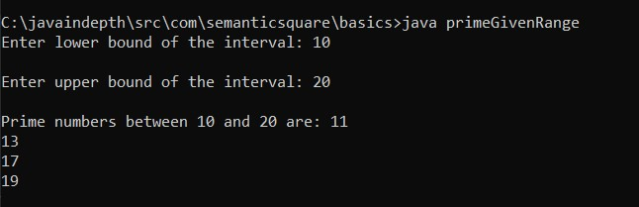

22.ANS:

SourceCode:

|  |
| --- |
| publicclassamrstrongnumber{ |
| publicstaticvoidmain(Stringargs[]) |
| {booleanisamsno=false;//bydefault |
| intrem,s=0; |
| intn=153; |
| inttemp=n; |
| while(n!=0) |
| { |
| rem=n%10; |
| s=s+(rem*rem*rem); |
| n=n/10; |
| } |
| if(temp==s){ |
| isamsno=true; |
| } |
| if(isamsno) |
| { |
| System.out.println("ITSAamrstrongnumber"); |
| } |
| else |
| { |
| System.out.println("ITSnotAamrstrongnumber"); |
|  |
| } |
| } |
| } |

Output:

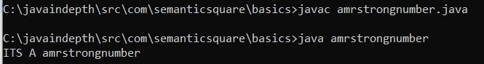

23.ANS:

SourceCode:

|  |
| --- |
| publicclasspattern1 |
| { |
| publicstaticvoidmain(String[]args) |
| { |
| introws=5,c=1,z=1; |
| System.out.println("##Printingthepattern##"); |
| for(inti=1;i<=rows;i++) |
| { |
| for(intj=1;j<=z;j++) |
| { |
|  |
| System.out.print(c+""); |
| c++; |
|  |
| } |
| z+=2; |
| System.out.println(); |
| } |
| } |
| } |

Output:

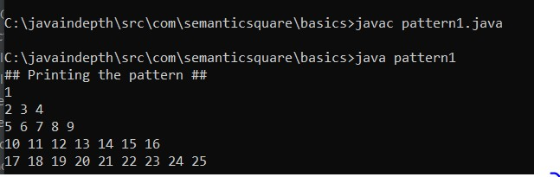

24.ANS:

SourceCode:

|  |
| --- |
| publicclasspattern2 |
| { |
| publicstaticvoidmain(String[]args){ |
| for(inti=1;i<=4;i++) |
| { |
| intn=4;//NO.OFROWS |
| for(intj=1;j<=n-i;j++){ |
| System.out.print(""); |
| } |
| for(intk=i;k>=1;k--) |
| { |
| System.out.print(k); |
| } |
| for(intl=2;l<=i;l++){ |
| System.out.print(l); |
| } |
| System.out.println(); |
| } |
|  |
| } |
| } |

Output:

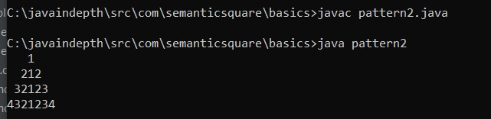

25.ANS:

SourceCode:

|  |
| --- |
| importjava.util.*; |
| publicclasspattern3{ |
| publicstaticvoidmain(String[]args){ |
| Scannersc=newScanner(System.in); |
| inthight; |
| System.out.println("Entertheno.ofRows:"); |
| hight=sc.nextInt(); |
| introwLen=(hight-1)*2; |
| for(inti=0;i<hight;i++){ |
| intstart=i; |
| intend=rowLen-i; |
| for(intj=0;j<=rowLen;j++){ |
| if(j==end){ |
| System.out.println(i); |
| break; |
| } |
| elseif(j==start){ |
| System.out.print(i); |
| } |
| else{ |
| System.out.print(""); |
| } |
| } |
| } |
| } |
| } |

Output:

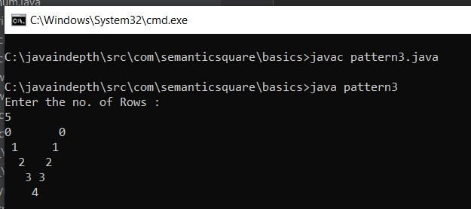

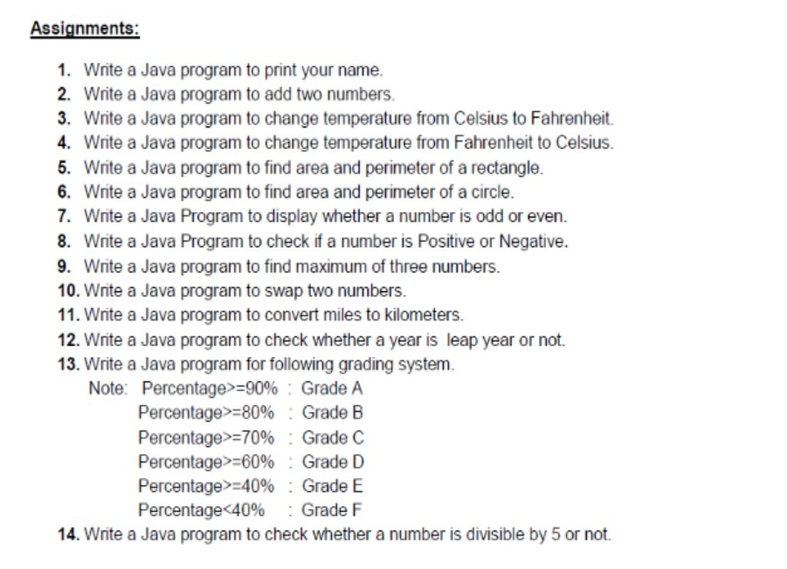

1.ANS: CODE:

publicclasshelloworld{ publicstaticvoidmain(String[]args){

System.out.println("HelloWorld");

}

}

OUTPUT:

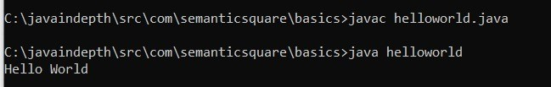

2.ANS:

CODE:

importjava.util.Scanner; publicclassaddtwoNo

{

publicstaticvoidmain(String[]arg)

{

inta,b,c;

Scannersc=newScanner(System.in); System.out.println("Enterfirstnumber"); a=sc.nextInt();

System.out.println("Entersecondnumber"); b=sc.nextInt(); c=addition(a,b);

System.out.println("Additionoftwonumbersis:"+c);

}

staticintaddition(intx,inty)

{

returnx+y;

}

}

OUTPUT:

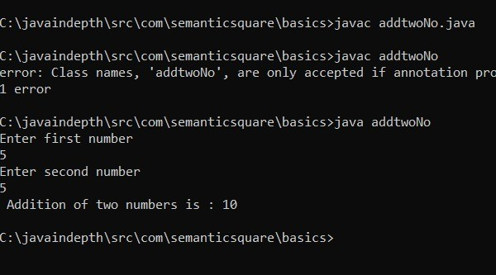

3.ANS:

CODE:

importjava.io.BufferedReader; importjava.io.IOException; importjava.io.InputStreamReader;

publicclasscelciusToferhenhite{

publicstaticvoidmain(String[]args)throwsIOException{

BufferedReaderreader=newBufferedReader(new InputStreamReader(System.in));

System.out.print("PleaseentertemperatureinCelsius:"); doublecelsius=Double.parseDouble(reader.readLine()); doublefahrenheit=(9.0/5.0)*celsius+32;

System.out.println("TemperatureinFahrenheitis:"+fahrenheit);

}

}

OUTPUT:

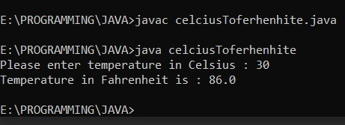

4.ANS:

CODE:

importjava.util.Scanner; publicclassFerhenhiteToCelcius{

publicstaticvoidmain(String[]Strings){

Scannerinput=newScanner(System.in); System.out.print("InputadegreeinFahrenheit:"); doublefahrenheit=input.nextDouble();

doublecelsius=((5*(fahrenheit-32.0))/9.0);

System.out.println(fahrenheit+"degreeFahrenheitisequalto"

+celsius+"inCelsius");

}

}

OUTPUT:

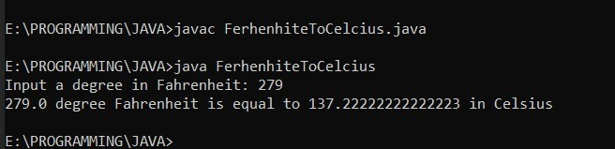

5.ANS:

CODE:

importjava.util.*;

publicclassparameterAndArea{

doublelength; doublewidth; voidArea()

{

doublearea; area=this.length*this.width; System.out.println("Areaofrectangleis:"

+area);

}

voidPerimeter()

{

doubleperimeter;

perimeter=2*(this.length+this.width); System.out.println("Perimeterofrectangleis:"

+perimeter);

}

}

classUse_Rectangle{

publicstaticvoidmain(Stringargs[])

{ parameterAndArearect=newparameterAndArea();

rect.length=15.854;

rect.width=22.65;

System.out.println("Length="+rect.length); System.out.println("Width="+rect.width);

rect.Area();

rect.Perimeter();

}

}

OUTPUT:

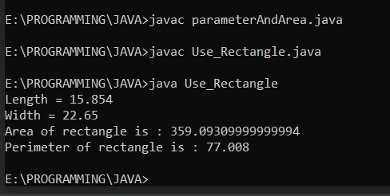

6.ANS:

CODE:

importjava.util.Scanner; publicclassCircleAreaAndParameter

{

publicstaticvoidmain(String[]args)

{

intr; doublepi=3.14,area; Scanners=newScanner(System.in);

System.out.print("Enterradiusofcircle:"); r=s.nextInt();

area=pi*r*r;

System.out.println("Areaofcircle:"+area); doubleparaMeter;

paraMeter=2*pi*r;

System.out.println("Parameterofcircle:"+paraMeter);

}

}

OUTPUT:

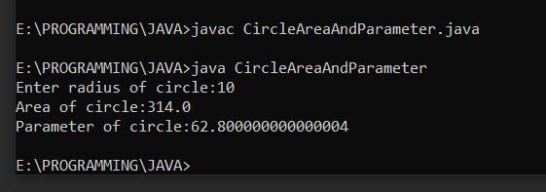

7.ANS: CODE:

importjava.util.Scanner;

publicclassevevOddCheck{

publicstaticvoidmain(String[]args){

Scannerreader=newScanner(System.in);

System.out.print("Enteranumber:"); intnum=reader.nextInt();

if(num%2==0)

System.out.println(num+"iseven"); else

System.out.println(num+"isodd");

}

}

OUTPUT:

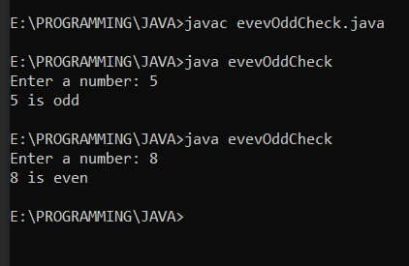

8.ANS:

CODE:

importjava.util.Scanner; publicclassPositiveNegative

{

publicstaticvoidmain(String[]args)

{

intnumber;

Scannerscan=newScanner(System.in);

System.out.print("Enterthenumberyouwanttocheck:"); number=scan.nextInt(); scan.close(); if(number>0)

{

System.out.println(number+"ispositivenumber");

}

elseif(number<0)

{

System.out.println(number+"isnegativenumber");

}

else

{

System.out.println(number+"isneitherpositivenornegative");

}

}

}

OUTPUT:

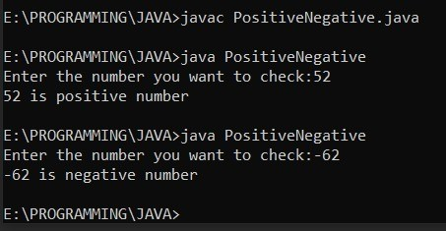

9.ANS:

CODE:

importjava.util.Scanner; publicclassthreeNumbers

{

publicstaticvoidmain(String[]args)

{

intx,y,z;

Scanners=newScanner(System.in);

System.out.print("Enterthefirstnumber:"); x=s.nextInt();

System.out.print("Enterthesecondnumber:"); y=s.nextInt();

System.out.print("Enterthethirdnumber:"); z=s.nextInt();

if(x>y&&x>z)

{

System.out.println("Largestnumberis:"+x);

}

elseif(y>z)

{

System.out.println("Largestnumberis:"+y);

}

else

{

System.out.println("Largestnumberis:"+z);

}

}

}

OUTPUT:

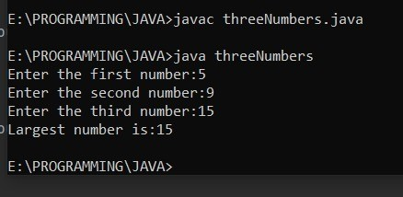

10.ANS:

CODE:

importjava.util.*;

classswapTwoNum{ publicstaticvoidmain(String[]args){ intx,y,t;//xandyaretoswap Scannersc=newScanner(System.in); System.out.println("EnterthevalueofXandY"); x=sc.nextInt(); y=sc.nextInt();

System.out.println("beforeswappingnumbers:"+x+""+y);

/*swapping*/ t=x; x=y; y=t;

System.out.println("Afterswapping:"+x+""+y); System.out.println();

}

}

OUTPUT:

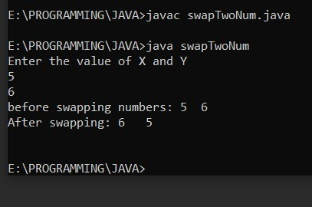

11.ANS:

CODE:

importjava.util.Scanner; publicclassMilesToKilom{

publicstaticvoidmain(String[]args){

System.out.print("Enterdistanceinmiles:"); Scanners=newScanner(System.in);

doubledistanceInMiles=s.nextDouble();

System.out.println(distanceInMiles+"miles="+ milesTokm(distanceInMiles)+"km");

System.out.print("Enterdistanceinkm:"); doubledistanceInKm=s.nextDouble();

System.out.println(distanceInKm+"km="+ kmTomiles(distanceInKm)+"miles");

s.close();

}

privatestaticdoublemilesTokm(doubledistanceInMiles){ returndistanceInMiles*1.60934;

}

privatestaticdoublekmTomiles(doubledistanceInKm){

returndistanceInKm*0.621371;

}

}

OUTPUT:

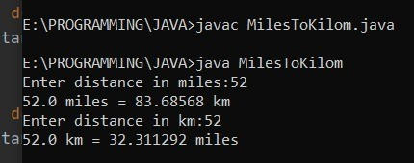

12.ANS:

CODE:

publicclassleapYr{

publicstaticvoidmain(String[]args){

//yeartobechecked intyear=1996; booleanleap=false;

//iftheyearisdividedby4 if(year%4==0){

//iftheyeariscentury if(year%100==0){

//ifyearisdividedby400 //thenitisaleapyear if(year%400==0)

leap=true;

else

leap=false;

}

//iftheyearisnotcentury else

leap=true;

}

else

leap=false;

if(leap)

System.out.println(year+"isaleapyear."); else

System.out.println(year+"isnotaleapyear.");

}

}

OUTPUT:

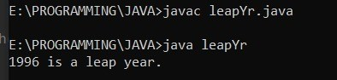

13.ANS:

CODE:

importjava.util.Scanner; publicclassGradingSystem{

publicstaticvoidmain(String[]args){ Scannersc=newScanner(System.in); doublepercent;

System.out.println("EnterNumberOutof100::"); percent=sc.nextDouble(); if(percent>=90)

{

System.out.println("GRADE-A");

}

elseif(percent>=80)

{

System.out.println("GRADE-B");

}

elseif(percent>=70)

{

System.out.println("GRADE-C");

}

elseif(percent>=60)

{

System.out.println("GRADE-D");

}

elseif(percent>=40)

{

System.out.println("GRADE-E");

}

else{

System.out.println("GRADE-F");

}

}

}

OUTPUT:

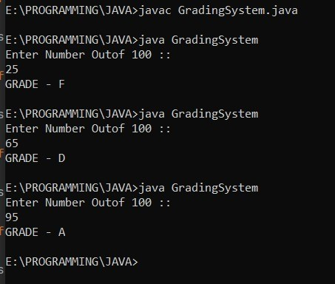

14.ANS:

CODE:

importjava.util.Scanner; publicclassDivisbleBy5

{

publicstaticvoidmain(String[]args)

{

intn;

Scanners=newScanner(System.in); System.out.print("Enteranynumber:"); n=s.nextInt(); if(n%5==0)

{

System.out.println(n+"isdivisibleby5");

}

else

{

System.out.println(n+"isnotdivisibleby5");

}

}

}

OUTPUT:

